Chapter 10
How to Do a Self-Management Project

O.K., hopefully, you're fired and wired and not too tired. Hopefully you're ready to practice our preaching. Hopefully you're up for doing your own performance management project either managing your own performance or helping someone else manage theirs. Here are a few guidelines and suggestions, some general self-management procedures we've talked about, hinted at, implied, or forgot to mention-expressed in terms of managing your own performance, but you can easily translate them into helping someone else manage their own performance:
THE SIX STEPS OF BEHAVIORAL SYSTEMS ANALYSIS

Step 1. Analyze the Problem

The ineffective natural contingency
- Specify the ineffective natural contingency you're concerned with. This is the contingency you wish were controlling your behavior but isn't. Here are some criteria from the three-contingency model of performance management: they should help.
- Criterion: Natural contingency- A natural contingency is operative prior to performance management, and it is not designed to manage performance. It is usually built-in (intrinsic), not added (extrinsic).
- Criterion: Quality of Life- The natural contingency must have an outcome that affects the quality of life of the individual or society, for us to be concerned with it. In other words, this is why you give a damn in the first place. The ineffective outcome is important to you, even though it isn't controlling your behavior.
- Criterion: Ineffective Contingency- The natural contingency must be ineffective; that is, it must not control behavior, otherwise we wouldn't need to do performance management.
- Criterion: Small Outcome- A contingency is ineffective, if the change in the size of the
outcome from the before condition to the after condition is too small to control behavior. For example, the permanent increase in weight and cholesterol count from eating that one fudge sundae is too small to suppress eating that sinful delight, even though the cumulative effect of those 1,000 fudge sundaes you've eaten has been disastrous or will be if you're too young to have hit the big 1-0-0-0 mark yet. These outcomes that are small, but of cumulative significance, are the ones that cause most of our self-management problems.
- Criterion: Improbable Outcome- A contingency is ineffective, if the change in the probability of the outcome from the before condition to the after condition is too small to control behavior. That's why most people have so much trouble putting on their seat belts. The very low probability of being injured on this next trip decreases only infinitesimally when you buckle up, hardly enough to bother with, right? . . . Splat! Usually the contingency is ineffective either because the outcome is too small or too improbable.

Now that you've checked out the criteria, it would be nice to diagram your ineffective natural contingency. And indicate whether it is an ineffective reinforcement, escape, or avoidance.

The effective natural competing contingency
- Suppose the behavior is something you want to decrease, like eating those sundaes. Then the ineffective natural contingency is some sort of ineffective punishment or penalty contingency. But if the sinful behavior is occurring, it's occurring because of some sort of effective, natural reinforcement or escape contingency that is effectively competing with the ineffective natural contingency. At least as far as fudge sundaes and other garden-variety sins, it no longer seems plausible to just say, the devil made me do it.
- Suppose the behavior is something you want to increase, like studying. Then the ineffective natural contingency is some sort of ineffective reinforcement, escape, or avoidance contingency. And there may be no effective natural competing contingency. It may simply be that even without any competition, the natural supporting contingency is too weak to be effective because the outcome is just too small or too improbable. But, on the other hand, there often are effective natural competing contingencies; and they can be of two types -punishment and penalty. For example, the punishment of the effort required to study may be great enough to suppress most of your studying. And the penalty of loss of the opportunity to watch your favorite soaps may be great enough to suppress most or all of your studying, at least when the soaps are on.
It would be nice to diagram what you think are the most important of the effective competing contingencies. And indicate whether they are reinforcement, punishment, or penalty contingencies.
- Do a functional analysis. This whole analysis step is roughly analogous to the functional analysis of applied behavior analysis, where you experimentally determine the natural contingencies maintaining or suppressing the behavior of interest. If you can actually do a functional analysis, that would be wonderful.
- Record your baseline performance. After you've specified your goal and your recording procedures, as discussed in the next sections, it would be a good idea to record the frequency of the behavior of interest, before you begin your actual intervention.

Step 2. Specify Your Goal

Specify a clear-cut goal you want to accomplish. Be very specific. Like I’ll write for four hours a day, or run three miles, or do 30 push ups, or can 24 quarts of tomatoes, or spend an hour crocheting. Be so specific and detailed in your specification that an independent observer can easily agree with you about when instances of that behavior are occurring and when they are not. In addition, if you're that specific, it will be harder for you to rationalize that you are behaving properly, when you're really not.
- Specify when you'll do it. Like everyday, Monday through Friday, or every morning, seven days a week, or at 10:00 A.M. Thursday.
- Specify the amount of product you're going to produce. If simply specifying the amount of time you're going to log it may not work, in other words, if you just sit there goofing off, specify the number of rows you're going to knit, the number of pages you're going to read, or whatever.
- Think small. Don't try to make up for your past sins in a single day. If you've got a hundred letters to write, don't contract to do them all right away. A postcard a day may be much better than you're doing now. Going for too much too soon is why many people fail at self-management. That's a big error, so watch out for it.

Step 3. Design Your Intervention

Here are some more criteria from the three-contingency model of performance management that should help you design an effective intervention:
- Criterion: The Added Performance- management Contingency- the contingency is usually added (extrinsic), not built-in (intrinsic).
- Criterion: The Analog to Avoidance Contingency- If an indirect-acting contingency is to increase or maintain performance; it should be an analog to avoidance.
- Criterion: The Analog to Punishment Contingency- If an indirect-acting contingency is to decrease performance; it should be an analog to penalty or punishment.
- Criterion: Deadlines for Avoidance-Deadlines are needed only for analogs to avoidance, not analogs to punishment.
- Criterion: Explicit Deadline- When there is a deadline, it must be explicitly stated in the S^{D} (Deadline).
- Criterion: Sizable Outcome- The change in the size of the outcome from the before condition to the after condition, must be large enough to control behavior.
- Criterion: Probable Outcome- The change in the probability of the outcome from the before condition to the after condition must be sizable for the contingency to control behavior.
- Just show and tell. Sometimes just recording data will get you where you want to go without an added performance-management contingency. It's O.K. to try it and see; but be prepared to slap on the fine, if need be.
- Put Satan behind you. Get rid of distractions. Try to do your work when and where no one can bother you. Watch out for that phone. And we can blow a whole morning sorting through our junk mail and new magazines. Get as many tempting distractions out of your work environment as possible. Put the ax to the TV set. This paragraph is talking about some of the effective natural competing contingencies.
My friend and colleague, Al Poling really did it. He threw his TV out the back door of his house in a fit of disgust, as much with the control the tube was able to exert over his own behavior as with the programming content. And when he found himself clearly headed toward consumption of a whole box of cookies, as he was driving home he threw them out the car window. That's how a real man of action tussles with old Lucifer. (But, as Al later pointed out, Of course, the Devil always returns, stronger.)
- Do the hardest things early in the morning. Famous writers usually get up early in the morning and do their writing when there are fewer distractions and when they are the sharpest and most energetic. And runners who hang in for a lifetime of running often run the first thing in the morning also (the percentage of running dropouts is higher with end-of-day joggers than early-morning joggers. So I try to put the most fragile thing first and the second most fragile thing second and so on. Usually that's writing and then running. The sad truth is that I have trouble reliably performing more than two major procrastinateable tasks on a daily basis, like after my writing and running, I've little time left to pay my bills, return my phone calls, and write those letters. Hey, I never said it would be easy.
- Don't blame it on Satan. Don't make the mistake of thinking that getting rid of the effective competing contingencies is all you have to do. Most often throwing out the TV will have only a small effect on the amount of time you study, because there may be no effective reinforcement contingency for studying, regardless of whether the soaps are blasting their way into your consciousness. In many interventions with low functioning clients, it is often the case that a functional analysis will reveal the natural competing contingencies and the problem is solved by simply removing those contingencies. But that will rarely be the case with the kind of devils you're confronting.
- Require daily performance, rather than weekly performance, especially if the total time to meet your weekly goal is more than you'd like to do in a single day. Otherwise, you're likely to wait until the last day you meet with your performance contractor and try to do all the work then. This is especially true, if the behavior is something you're having so much trouble getting yourself to do that you need a PM project for it.
So, if you want to study 10 hours a week, don't contract to have it all done by Sunday. Instead, contract to do 2 hours a day during the week days, or something like that, though it isn't bad to give yourself a little flexibility, in case an emergency comes up on Tuesday. You can do this by saying you must have your 5 days of studying done by Sunday or 4 of your 5 days done by Friday.
- Don't make your contingency all or nothing. Some students say, I'll pay $10, if I don't study 2 hours every day, Monday through Friday. So what happens if they blow off Monday? Then you've already lost your $10, so now there's no added incentive to keep you hanging in for the rest of the week. Better to say something like, I'll pay $2, for each day I fail to study 2 hours.
- Make it easy to pay the price. Otherwise you may cop out; you may sin and never get around to paying the fine. A good system is to give your performance manager some blank checks which he or she fills out each time you screw up or screw off. A variation is that you could fill out the checks, if you don't want to have a blank check floating around; but instruct your performance manager to use them only when appropriate.
- Add an explicit penalty for failure, if you need to. Tell your monitor you'll pay a quarter, or a dollar, or take him or her out to lunch for each of your failures. But keep the penalty small, almost at the joke level, otherwise, every one will start getting up tight and you're liable to fib a bit.
- Get a tough, reliable performance manager. Get someone who's into whips and chains and black leather. You don't want no pussycat you can talk out of implementing the fine. And you want someone who will stay on your case, even when you forget; but a good performance manager is hard to find. This may be the most frequent weak link in the performance-management chain; this may be the part students need to recycle on most frequently, the search for a reliable performance manager.
- Make a public commitment. Tell someone what your goal and your deadline are. And even ask them to check on you to see if you got it done. That's a subtle way of arranging for a little mild social reinforcement or punishment, approval or disapproval, depending on whether you get the job done. No big deal, but it helps to have an external conscience in case yours doesn’t always do the trick.
- Set a timer that beeps every five minutes and chart whether you're on task, if you find yourself drifting off too much. This is especially good when you might have trouble measuring the amount of the product. Like when you're doing spring cleaning, but may get distracted too easily by Better Homes and Gardens.
- Use a reliability observer about 20% of the time, if you can, to make sure that you have procedural integrity. Procedural integrity means you're implementing your procedure accurately and reliably. We recommend that you check the procedural integrity of your self-management project. It's all too easy to kid yourself, otherwise. For example, your project will have little procedural integrity if you don’t record your data regularly, if you don’t pay the fine when you’re supposed to, or if you give yourself the reinforcer before you’ve earned it.
- Actually write a performance-management contract. Include all the details and have you and your conscience both sign and date it. As you recycle your goals and procedure, modify the contract and have you and your conscience both initial the changes. Specify and write down the goals, measures, and contingencies in such a clear, unambiguous manner that you and your conscience always agree about the interpretation. And when you do discover ambiguity, as you well may, clarify your contract.
- Don't use the prostitution contingency. Don't have your spouse or lover be your performance manager, with the contingency that if you fail to meet your goal, the two of you don't get to have sex. Why not? Because, if that doesn't guarantee that your performance manager will not enforce the contingency, then you've got a more serious problem than the one you're contracting for.
- Use an outcome that's aversive for you but a reinforcer for your performance manager. Like you'll pay your PM $5 if you screw up.

Step 4. Implement Your Intervention
To know and not to use, is not yet to know.–Ken Blanchard

A person of words and not of deeds is like a garden full of weeds. –Chinese fortune cookie.
- Arrange for regular contact with your conscience, your monitor, daily or weekly as needed. This is another one of those weak points in the system. It helps to put your self-management project on the agenda with someone you meet with regularly and formally, a superior, a peer, or a subordinate-it doesn't matter.
- Arrange for your conscience to monitor your graphing as well as your goal attainment. I think it's important to keep a good record of your performance so you'll be motivated not to mess up that pretty record; but you also might need to contract your charting, or that charting may fallout. The odds are you'll need to contract for every detail.
- Consider the three steps of performance management- specification, observation and consequation. It may be that simply specifying your desired performance is all that you need to do; so you might just try that for a while before you get any more complicated. If that's not enough; then you might just add the reporting to your conscience and see if that suffices. If you're still not where you want to be then bring in the heavy guns, the contingencies. Of course, you might not have time or the inclination to go through all three steps separately and may want to get right into the big-time performance-management contingencies; fine.

Step 5. Record Your Data
- Record your hit rate. Make a record of your successes and your failures. Like a graph of the number of hours per day, or a note on your calendar of the number of miles run each day. Select or design a graph with a y-axis (vertical axis) that covers only a slightly little higher range than you think you will need.
- Record your cheating. How often did you shade the truth a little on your data recording? And how much? And how often did you fail to pay the fine, when you should have? It happens.
Remember: Everyone cheats once in a while. The important thing is to blow the whistle on yourself, if your cheating is trashing your self-management project. You blow the whistle, and change things so it's harder for you to cheat in the future. The big sin is not cheating; it's failing to blow the whistle.
- Record daily. Daily recording of data helps you think about your performance goals each day and makes it more likely you'll stay on task. It is depressingly easy to forget that you're supposed to exercise today. Also, daily recording increases the accuracy of your records. It is depressingly easy to forget what you did on Monday when you go to record it on Friday.
- Record promptly. It's best to record your data as soon as the behavior occurs, or throughout the day, if immediately is inconvenient. At the very least, you should record your data once a day; but your data may not be too reliable if you wait until the end of the day, or worse yet, the beginning of the next day, to try to remember how many times you swore, how many calories you ate, or how much time you studied throughout the day.
- Use a permanent product, a permanent proof of accomplishment, if you can, for example, the number of pages you wrote. A variation on that, is to put in a special cigarette box, the number of cigarettes you're limiting yourself to for the day. Or, in the morning, prepare and set aside the food you're allotted for the day.
- Record the long-term benefits, also. For example, suppose you're contracting to diet. Well, also record your weight to see if you're getting any real benefit from your efforts.
- Use a reliability observer about 20% of the time, if you can, to occasionally make sure that you’re recording your data accurately. You can tell how accurate your records are by measuring interobserver agreement. Get someone else to record your behavior every so often. Then compare your records to theirs. If both records agree, you’ve got interobserver agreement and accurate records.

Step 6. Recycle
- Recycle. Your self-management project may not work the first time you try it. And it will certainly fall apart from time to time, so be prepared with some scotch tape and bubble gum to put it back together again. Remember you do not demean yourself by using these explicit self-management techniques. Use them and you’ll be in the company of the world’s most productive people.
- Get real. Students often find their eyes are bigger than their available time. So you want to exercise 7 days a week but after a few weeks you find that you never manage to do more than 5 per week. Then maybe you should get real and settle for 5.
- Christie wanted to walk on her dust gathering treadmill 20’ X 6. She tried her husband as her performance contractor, but he wasn’t tough enough; he always felt sorry for her. So she fired him and hired her son: she made his bed every time she failed to do her 20 minutes; and he showed no mercy.
- You will fall off the wagon. Realize it. Then don’t spend the rest of your life beating yourself up, calling yourself a weak moral degenerate. Just struggle back up on the wagon and keep movin’ ahead. Remember it is no sin to fall; it is only a sin if you fail to get back on.
Most people who manage to quit smoking, have to try several times before they succeed. And most people who manage to lose weight and keep it off, have to try several times before they succeed.
- Provide incentive to get back on the wagon. For example, suppose you require yourself to exercise 5 days a week or pay $5. And further suppose you’ve failed to exercise for the first 3 days of the week. That means you will have to pay the $5 regardless of whether you exercise the remaining 4 days. So to heck with it; why not blow off the rest of the week? So you need to revise your performance-management contract so that you’ve got something to lose for each day less than 5 days of exercise. You might say I’ll pay $5 for each day less than 5 days of exercise. Then if you only exercised 3 days, you’d have to pay $10. Or you might make it less drastic, like $1 or $2 for each blow-off day, depending on what’s big enough to get you back on the wagon, but not so big that you’ll cheat. You also might or might not want to keep the $5 penalty in for failing to exercise for the full 5 days; that gets a little tricky though.

The write up.

If you will be writing up your performance-management project for a class or an agency, you might use the various headings in this chapter as the headings for your report.

Self-management and Creeping Degeneracy

5:00 p.m., Sunday 3-9-1997: Finish 3-hour meeting with Kelly Hobbins, working on TBA newsletter.

5:30 p.m.: Go to Meijers to do weekly grocery shopping. I know it is dangerous to leave the house when I’ve still got work to do. I am scheduled to do committee paper work from 6:00 p.m. to 9:00 p.m. or pay $5 per hour of failure to adhere to schedule. I rationalize that I’ll be back almost by 6:00 p.m. and will argue with Conscience International for a waiver.

6:30 p.m.: As I load the groceries into the trunk of my car, I pull out two slices of whole-wheat pita bread, because I really am a little hungry, not too hungry, but I deserve them; it’s only 200 calories over my limit. And I will argue with Conscience International for a waiver, rationalizing that it is only 200 calories and not worthy paying my $50 penalty.

6:35 p.m.: Too tired to go home and work those three hours. Will argue with Conscience International for a wavier, of my $15 fine and go see the re-release of Star Wars. Rationalizing that I deserve it; I've been up and working and exercising since 4:00 a.m.

6:50 p.m.: Buy small box of air-popped popcorn without salt or oil at theater. Will argue with Conscience International for a wavier, rationalizing that it's only a few more calories over my existing extension of 200 calories, and it really is hard for me to go to a movie without popcorn.

9:00 p.m.: Pull two more pieces of whole-wheat pita bread out of the grocery bag in my trunk. Not that hungry, but I just feel like eating. Will deal with Conscience International (CI) later.

9:15 p.m.: One final piece of pita bread, while I unpack the groceries, hardly worrying about my rationalization.

9:20 p.m.: One swig of O.J. from the new jug as I put it in the fridge, washing down the pita bread, and then another and another, until I notice I've made a reasonable dent in the level of juice in the jug.

9:30 p.m.: Go to bed thinking that the bland food (pita bread cold, not even nuked in the microwave) and the flick not really anything I care about, a lame unscheduled evening on the town CI should charge me a total of $85 for.

4:30 a.m., Monday: Weight: 2 pounds up from yesterday morning. Figure up my calories and see that I hit 3,200, rather than my allotted 2,400. Waver on whether to try to blow it off and plead with CI. Worry that this is the second time I've done this in the last week. A bad trend may be evolving. Better to pay the $50 than to blow the overall diet program that's been working so well. And what's $25 on top of the $50, so I might as well have a really clean conscience and pay a total of $75. It's worth it, if this will keep me from sliding further into degeneracy. Will add to my diet contract, that I can no longer make exceptions for intentional violations of the limit, no matter how small; might still tolerate the occasional unintentional accidental excess (if it doesn't get out of hand). Feel better. Clean conscience. Besides, yesterday had been excellent, except for my evening of pita, Star Wars, orange-juice degeneracy.
The spirit is willing, but the flesh is hamburger. That’s why we need to use performance-management contingencies. –Uncle Dickie

The Follow-Through

There are a lot of good ideas in this book, and probably some bad ones too. Ideas about what the good life is and ideas about how to help yourself do what it takes so you can live that illusive good life. Many of the ideas are other people's. Some are mine. Many of the suggestions are based on solid, scientific data. Many are based on self-recorded, self-reported case studies, not solid science but, at least, a nice, empirical step in the right direction. All the ideas have been put to the test, either by my students or me. Few self-help books can make that claim; perhaps none that cover the wide range of what constitutes the good life, as is covered in this book.

You may have found that all of these ideas and suggestions could help you personally live the good life, or maybe most of them, or maybe only a few. If you didn't find anything in here that could help you improve your life, then you're really pathetic; but I know you too well to ever believe you're pathetic. You wouldn't have gotten all the way through this book, if you were pathetic.

And now comes the hard part:
- Select half-dozen ideas you'd like to work on.
- Tattoo them on your arm.
- Tattoo a check mark by the ones you're going to start working on now.
- When you get a couple well implemented, go back to the tattoo parlor; have the ones you've “mastered” underlined, and have check marks put by the ones you're going to go for next.
- Set your MS Outlook task reminder to prompt you every month to review how you're doing on your procrastination projects, so you can consider the revising you need to do.
- Realize you will be working on most of these the rest of your life, no autopilot cruise control.
- Oh, yes, and you might want to skim through Procrastination once a year, just for a little refresher.

Benefit Measure

We've also started playing with a new measure; we call the benefit measure-a measure of one or more of the benefits of your self-management intervention. Here are some examples:
- You study for the GRE, and your self-management measure is number of hours studied per day or week. But your benefit measure is how much you improved on the GRE.
- You reduce your smoking, and your self- management measure is number of cigarettes smoked per day or week. Your benefit measure might be improved lung capacity in terms of peak airflow volume (cubic centimeters per second) as measured by a device you can get at a pharmacy for $16. (Tip of the hat to David Sidener.)
- David Bradshaw's self-management measure was miles he ran each day. His weekly benefit measure was how fast he could run a mile.
- Holly Harrison measured amount of aerobic exercise per day. And to assess some of the benefits she used the step test, the number of times per minute she could step up and then down on a one-foot step or stool. She also measured her resting heart rate (best done as soon as you wake up and before you get out of bed, but whenever is better than never). And she measured the speed with which her heart rate recovered after strenuous exercise (her pulse for 10 seconds immediately after exercise, 1 minute after exercise, 2 minutes later, etc.)
- Kip Den Hartigh is working on exercises that will allow him to touch the rim of the basketball hoop. His benefits measure is how high he can jump once a week.
- Scott Maieritsch’s benefit measure for weight lifting is the maximum weight he can lift.
- Wayne Sager did cleaning his apartment for his self-management project. He measured the number of 30-minute cleaning sessions he did each week. Here’s his graph:
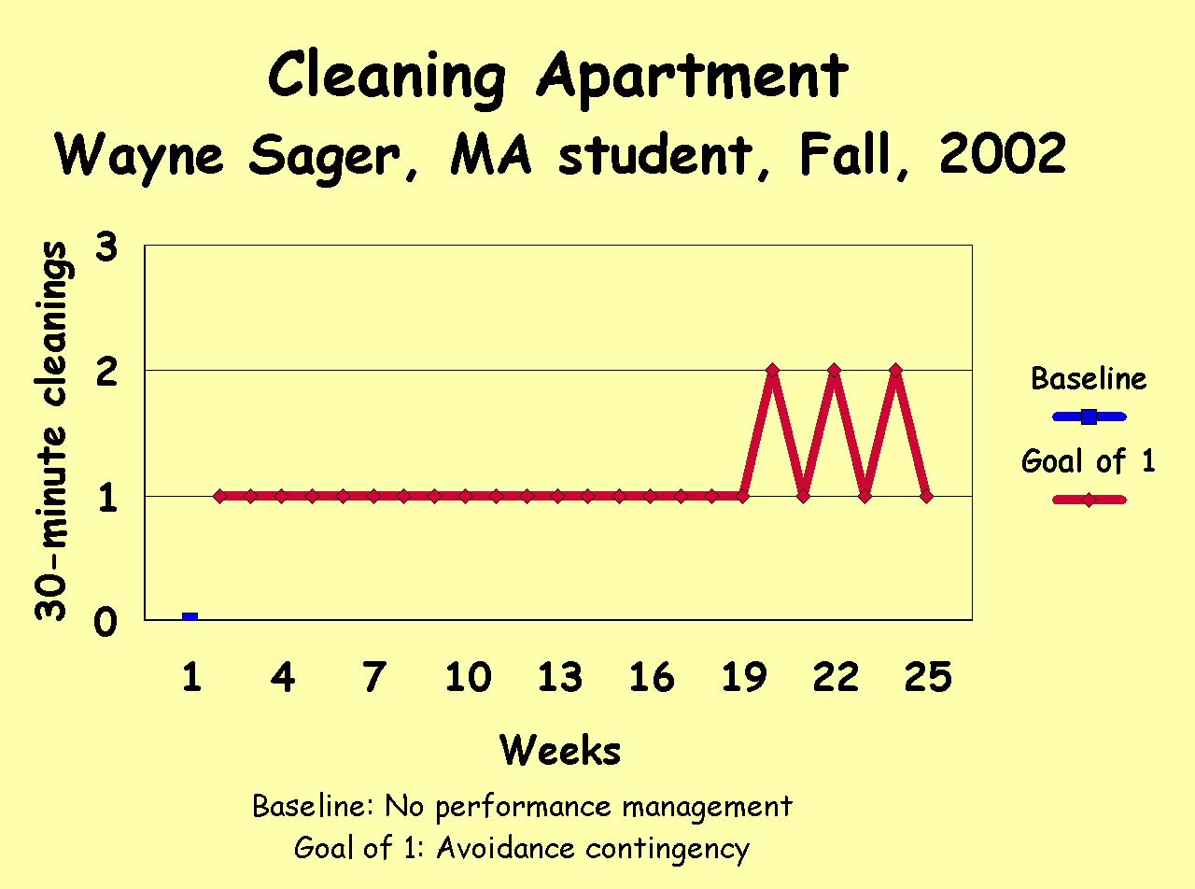

For his benefit measure he asked his roommate to rate the cleanliness of the apartment each week. The more he cleans, the better his roommate’s rating should be. Here’s his benefit graph:
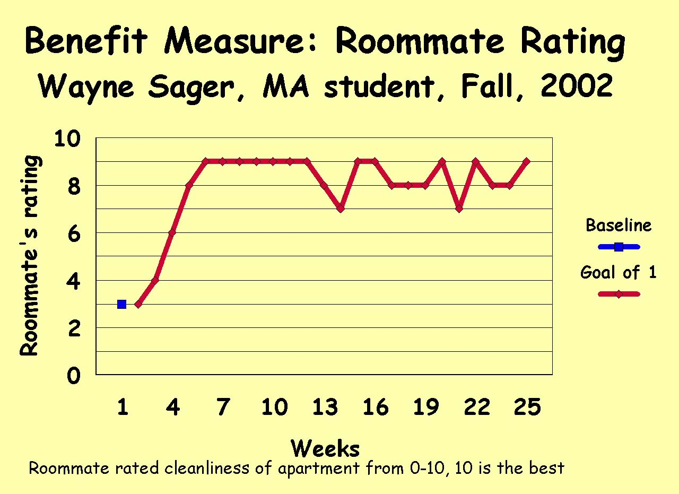
- Nathalie Witt worked on practicing yoga. She measured how many yoga sessions she performed each week. Here’s her graph:
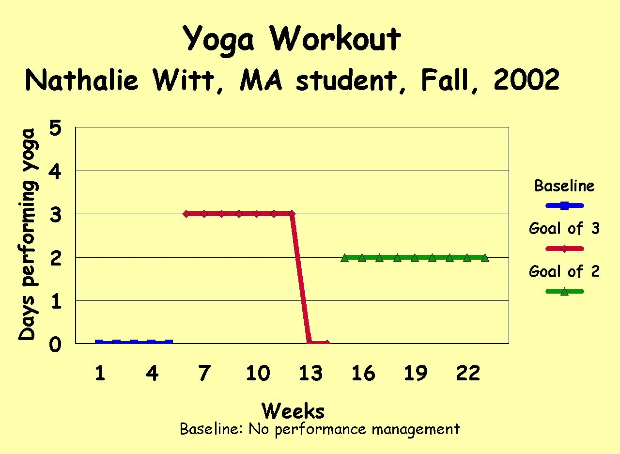

For her benefit measure, she checked how far she could stretch. She measured inches from her knee to the floor. Here’s her benefit graph:
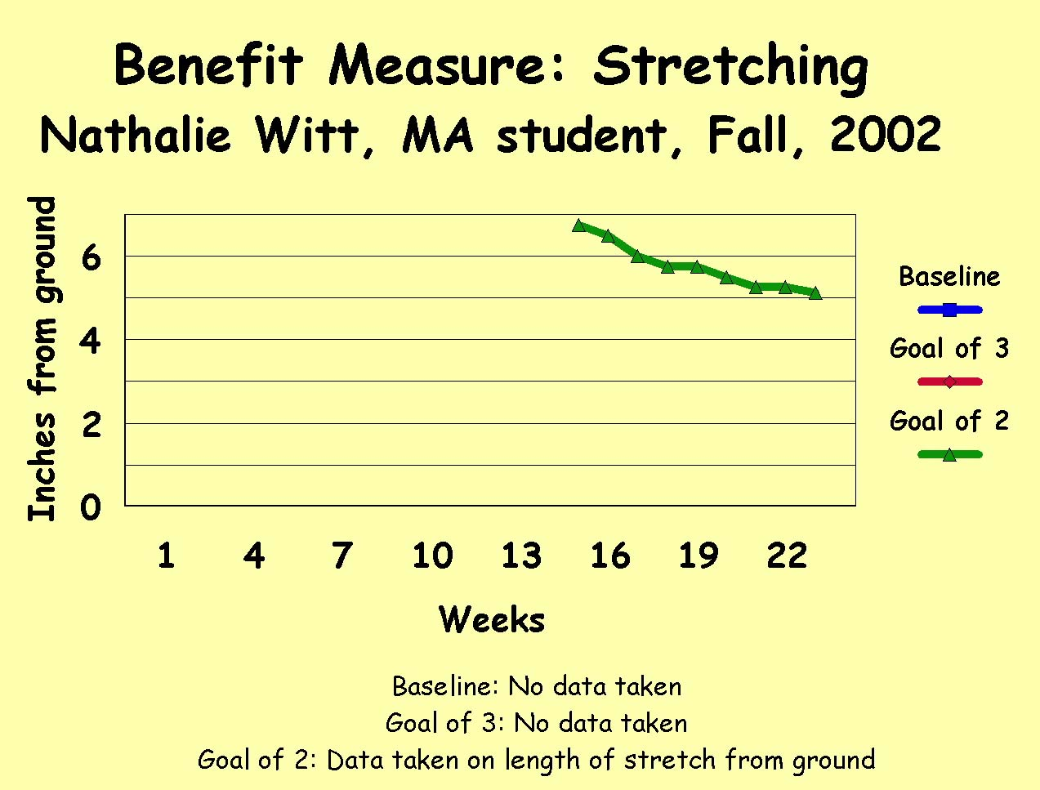
- Megan Coatley wanted to start taking an iron supplement every day. She recorded the number of days she took these vitamins each week. Here’s her graph:
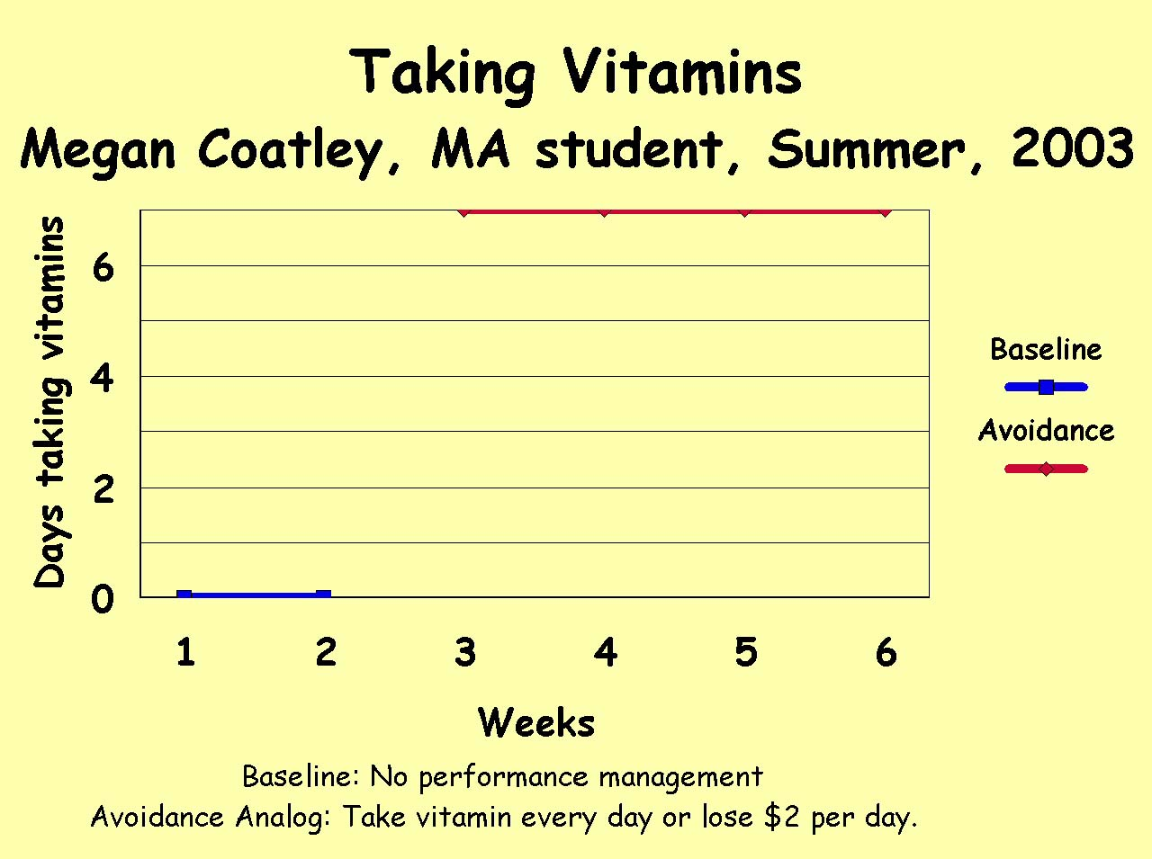

One of the reasons Megan wanted to take her vitamins was to help reduce the number of bruises she got. So at the end of each week she measured how many bruises she had; this was her benefit measure. And sure enough, she was getting less bruises after only a couple weeks of consistently taking her vitamins. Check out her benefit graph:
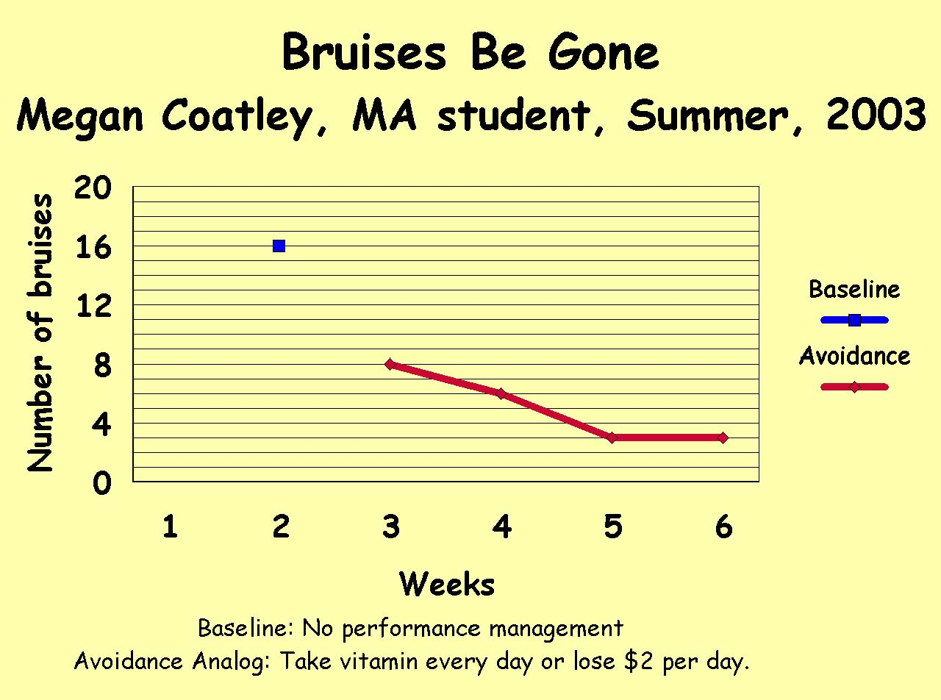

It's really a good idea to get a benefit measure for your project as well.

Sample Student Projects
- Summer worked on buckling up.
- One student contracted to spend 1/2 hour with God every day, reading the Bible or praying.
- As one of her PM projects, Rachel contracted to spend 1/2 hour/week thinking about application of concepts of behavioral concepts.
- Heather wanted to spend more quality time with her son. She contracted to get up at 6:00 AM every weekday morning, so they'd have a pleasant and valuable 1/2 hour or hour together before she put him on the school bus. It worked well; both she and her son enjoyed their new time together.
- One student contracted to spend some time each day making sure her hair and makeup were cool.
- Emalee wanted to take her vitamins more reliably. So she implemented a PM contract. It worked well, and she liked seeing the points she was earning.
- Melanie worked on what she decorously calls her “potty mouth."
- Ann wanted to study German ½ hour a day 5 days a week, not for a class, just because she wanted to get her German a little tighter.
- One student used as a fine, the loss of the opportunity to go out on weekends. Hhmm. He said his mom would be his performance manager and she was experienced in implementing that contingency. Hhmmm.
- Water girl #1. Jody Otten worked on increasing the number of glasses of water she drank to 8 per day. Health reasons.
- Water girl #2. Amy Christensen went for 64 oz of water/day. Had trouble and had to pay Mom $40 of fines. Mom was doing 48 oz with success. Recycle time: Amy brought it down to 48 so she won’t have to give money to mom.
- Water girl #3. Amber pays $1 to her Nazi roommate if she fails to do her 64 oz.
- Super-tight time management. Andy setup dead- lines, throughout the day and paid fines for each missed deadline.
- Another decreased number of classes skipped.
- Several increased the number of hours studying per week.
- Several decreased or eliminated their smoking.
- Some have worked on eliminating their or their boy friend's chewing tobacco.
- One worked on balancing her check book.
- One student worked on procrastinating on home work. She'd always get it done but the quality was suffering because she didn't have enough time left to do a really good job. She had to pay her boy friend $2 on Saturday for every assignment not done, based on a list she previously had made for that week. She required herself to do 90% of her assignments early. Results: she went from 30 to 80 and finally 90% done early.
- One student required himself to work out five days by Friday morning to avoid teaching a martial arts class on Friday night to a group of kids. That initial design didn't work because if he went 3 days without exercising then he blew off the rest of the week because he had nothing more to lose.
- Kael required himself to do guitar drills 6 out of 7 days per week or pay $5 per week. It worked fairly well.
- Here's a project I really like; I find it quite moving: A grad student had a dying friend living in another town. She wanted to stay in touch with her friend and give her support; she wanted to write a weekly letter to her friend, but often didn't get around to it (it's hard to do ). But the student cared enough to use performance management. The result was that she reliably gave her friend love and support until the friend died.
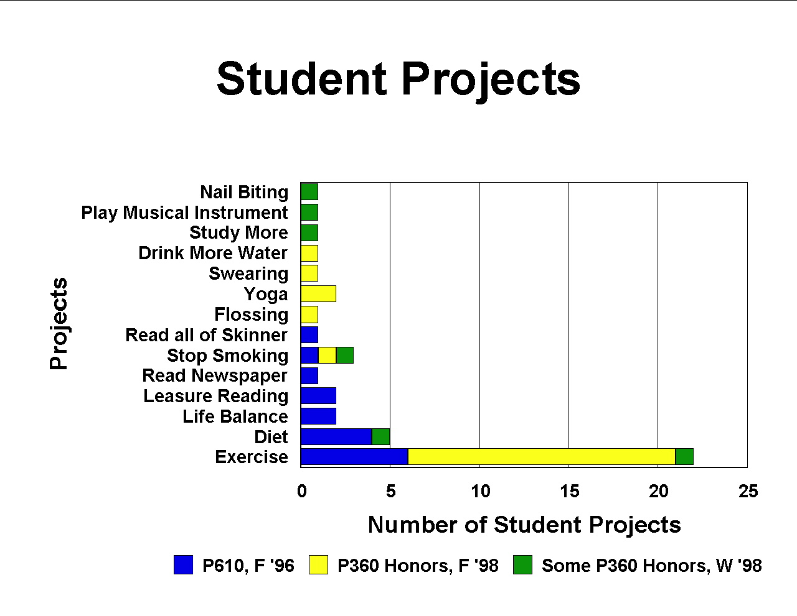

In the preceding graph, Life Balance means increasing the frequency of several activities. Five of 15 P610, F '96 students wanted to also start flossing, and 8 also wanted to increase their writing. Exercise includes running, lifting, doing push-ups, and using the stair stepper.

Follow-up: Life Balance
The Good-life Program
Dan Sikora, MA, Project Analyst, Meijer, Inc.

List of BATS projects:

Quitting Smoking
- Maintained after BATS: No.
- Did performance maintain w/o PM (performance Management)? No, back to the smoker's life
- Stopped because there were no sizable and probable PM outcomes.
- Have quit now (4 months, with only a few slips) because of pregnant wife and baby on the way-did not want to expose my unborn baby to smoke and did not want to model bad behaviors for my child!!

Weight Training
- Maintained after BA TS? No.
- Did performance maintain w/o PM? No, back to the slacker’s life.
- Stopped because there were no sizable and probable PM contingencies.

Running/Jogging
- Maintained after BATS? No.
- Did performance maintain w/o PM? No, back to the slacker’s life.
- Stopped because there were no sizable and probable PM contingencies.

The Good-life Program

A few coworkers and I have put together a program- The Good-life Program. We are using PM technology to get back on the track to the good life! I am the performance manager; it works like this: It costs 40 bucks to buy in; I hold on to it.

You decide what you need to work on to get on the path to the good life and set contingencies on those behaviors; these are recorded in a weekly contract.

Here are the areas different people are currently working on: aerobic exercise, anaerobic exercise (weights, calisthenics, etc.), yoga, diet (quantity), no junk food, no more than one cappuccino/day, vitamins, 8 glasses of water/day, body measurements (to see if the diet and exercise are working).


Everyone must report to me on a daily basis: 9 A.M. on weekdays and 12 P .M. on weekends (phone or e-mail). If you don't report that is the automatic loss of two bucks.

I then monitor everyone's progress and record the data in an Excel spreadsheet; at the end of each week I send out an e-mail containing:
- The Good Life List A big hooray for everyone who was successful for the week
- The Losers List People who failed (where they failed) and how much money they lost

The money lost is put back into the system- we are saving up for a scale that reads weight and body fat. First four weeks raked in 49 bucks!!!

The contingencies are put on behaviors, but we also weigh in every Tuesday at work, all together. Just to keep people (reporting) honest.

Finally we will meet each month to get the money back we have not lost and show our graphed data in power point format.

And then it all starts over again!

This is a very tight system- I have been called a bastard PM manager (among other things). It is what people need, I guess because it is controlling behavior. We are modeling our program after the eternal flame that burns under all our butts everyday to make this work-the avoidance contingency!

Dr. Malott I haven't felt this good in so long; I'm working out (aerobic and weights), eating healthy, and getting the caffeine monkey off my back. Never thought I would be here. Aaaaaaaahhhhhhhhhhh the good life and I owe it to PM. Recording and social contingencies are working for me, but I am open to putting cash on anything if it starts slipping.

Well, I am still fat (working on it), but very happy. If I left it up to the small but cumulative natural contingencies, I would have quit a long time ago. Looking forward to seeing you at ABA; look for the skinny kid!!

Comments

Dan, Maria, April, Corina, Lori, and Mr. X:

I'm really proud of you guys. You're doing exactly what needs to be done, setting up a self-management project in the work place. You're the first to do it. I hope others follow in your foot steps.

Uncle Dickie


Life Balance
Jeff Hoxworth, MA Student, 1998

Becoming a Beefcake

I started the exercise program during Psy Psy 610 in the fall, and I kept going afterwards for a year and a half, but have no data, for that follow-up. Once I started BATS, I decided I must work out initially three times a week, and then four times a week. The activities included either 45 minutes working out at the gym, or at least 1 mile running per day. If I missed more, I paid $10 for each additional day missed! Analog to avoidance.
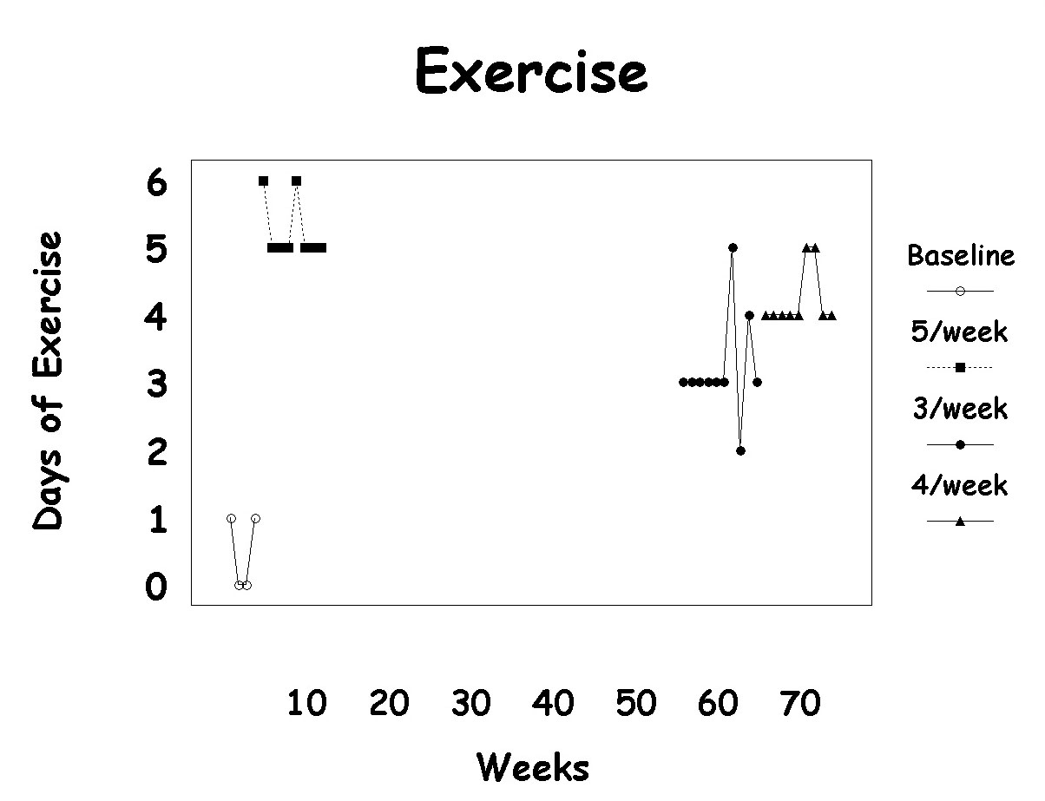

I’ve paid out only four times. . . this works well.

To Be a Fat-Ass

I must stay under 15 grams of fat, or pay $2. If I exceed 20 grams on a given day, I pay $10. Analogs to penalty.
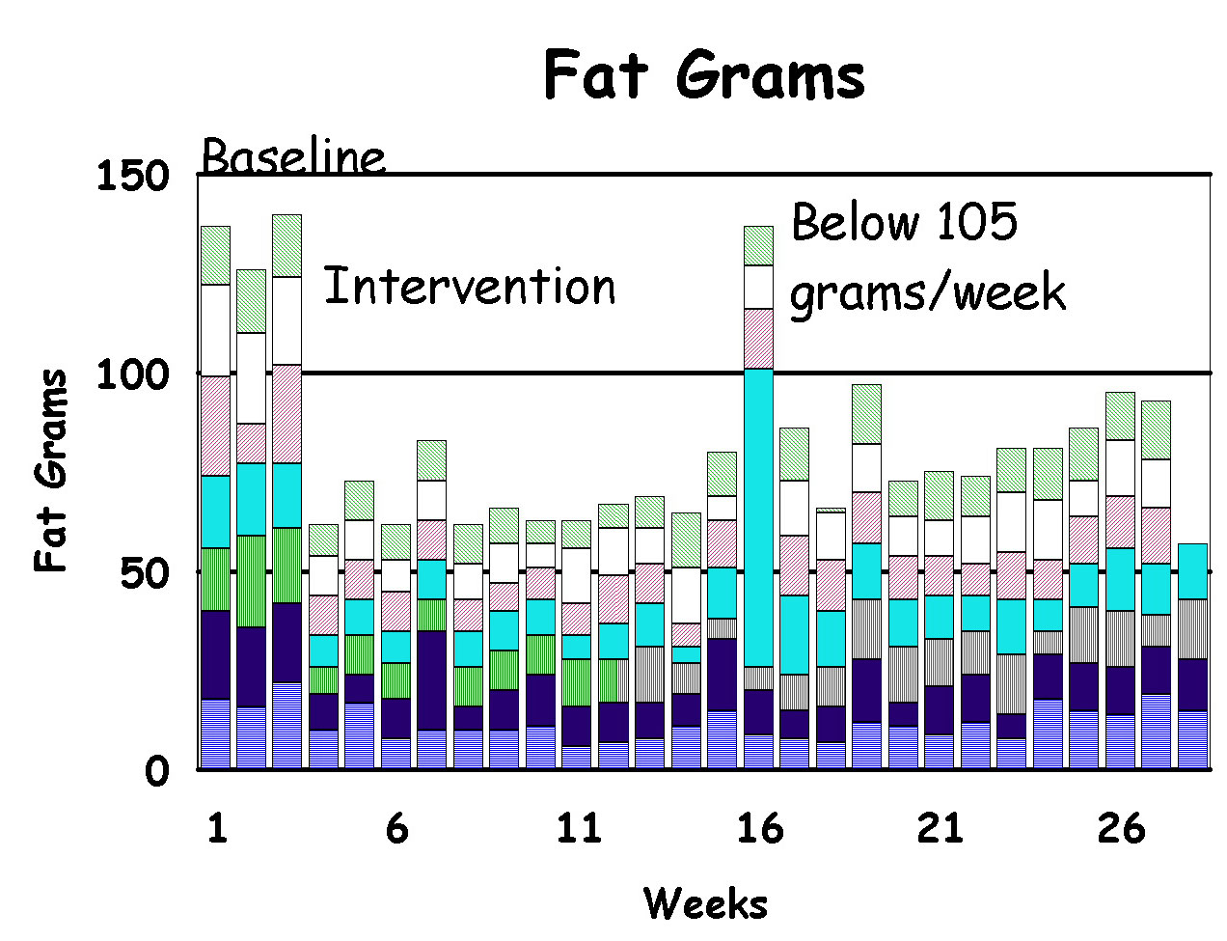

Haven’t had too many payouts so far.


Gimme a beer, Damn it!

I can’t drink, period. If I drink, I must pay $10. This runs until May 1st (excluding a couple days, like graduation!) From the point of intervention, I did not drink until the deadline I had imposed on myself, which was the completion of my MA paper! I had no slip-ups, which surprised me, but I think the social contingencies influenced me too. I actually enjoyed having Brian, Don, Pat, Angie and Michelle constantly trying to make me fold. It gave me a chance to demonstrate my resolve. But I digress . . . The point is, I did not have a single drink from the beginning of the intervention until April 17th (the last day of classes).
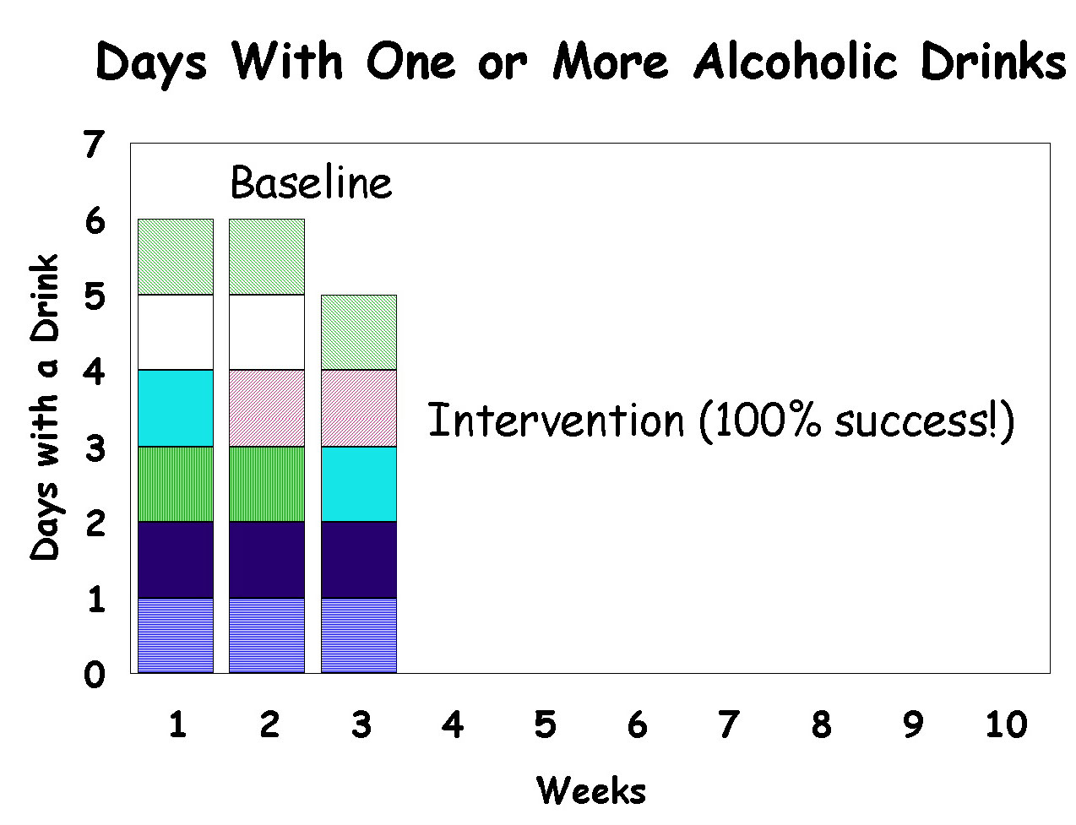

Follow-up:

The exercise contingency has not been recycled since graduating – I got off track for a while, but I found a new performance manager and am back to running and working out.

On a sadder note, a main motivation for my self-improvement was the desire to date Michelle. But when that happened, the motivating force declined a bit. So I like to blame her as well as myself for my 3-month slip back into the abyss!!!!

I don’t keep tabs anymore, but my eating style hasn’t changed significantly since BATS. The change in lifestyle suited me fine, and to tell you the truth, I can’t eat the things I used to, without feeling terrible (physically and mentally) afterwards! The drinking comes and goes in stages . . .depends on when I see the guys.

J. Thomas Hoxworth, MA

Triad Performance Technologies Inc.


Follow-up: Life Balance
Jaci Smeltzer (MA and Ph.D. student ,1996-2000)

Exercise

Reinforcement contingency (can't remember what the reinforcer was, something like I get to treat myself to a movie if I exercise 3x a week for a month. Baseline average frequency: O/month. During PM contingency got it up to about 10/month. Maintained for one year after BATS and then fell apart.

Apologizing

The problem is, I was almost continuously apologizing, even when no apology was called for. My baseline average frequency was about 50/week. So I used on analog to a punishment contingency: I'd pay $.50 per apology. I lost about $80.00 (scary) in one semester. I kept the performance-management contingency for about a year, until my frequency of apologizing was down to about 5/week. And I've kept it that low since then (anecdotal data).

Arriving Late

My baseline frequency for arriving late was 10/month. So I used a punishment contingency: social disapproval and verbal scolding (mainly from Beth) and got it down to 1/month. I maintained this contingency for about one semester; then it fell out. However, I restarted a performance-management contingency last semester. The new contingency is an analog to avoidance of the loss of a reinforcer: I owe $5 to my PM manager each time I'm late. The results are that now I'm never late.


Life Balance and Aging

 | ORGAN OR SYSTEM | NATURAL EFFECTS OF AGING | ACCELERATING FACTORS
 | Skin | - Loses thickness and elasticity (wrinkles appear) | Process accelerated by smoking, excessive exposure to sun
 |  | - Bruises more easily as blood vessels near surface weaken
 | Brain/Nervous System | - Loses some capacity for memorization and learning as cells die | Process accelerated by overuse of alcohol and other drugs, repeated blows to the head
 |  | - Becomes slower to respond to stimuli (reflexes dull)
 | Senses | - Become less sharp with loss of nerve cells | Process accelerated by smoking, repeated exposure to loud noise
 | Lungs | - Become less efficient as elasticity decreases | Process accelerated by smoking, poor air quality, insufficient exercise
 | Heart | - Pumps less efficiently, making exercise more difficult | Process accelerated by overuse of alcohol and tobacco, poor eating habits
 | Circulation | - Worsens, and blood pressure rises, as arteries harden | Process accelerated by injury, obesity
 | Joints | - Lose mobility (knee, hip) and deteriorate from constant wear and pressure (disappearance or cartilage between vertebrae results in old age “shrinking”) | Process accelerated by injury, obesity
 | Muscles | - Lose bulk and strength | Process accelerated by insufficient exercise, starvation
 | Liver | - Filters toxins from blood less efficiently | Process accelerated by alcohol abuse

This table suggests the long-run importance of a life-balance program dealing with diet (quantity and quality), exercise, smoking, alcohol, other drugs, and sun tanning, as well as loud rock & roll (oh, oh) and air quality. In other words, we're all going to grow old and die, but the speed and grace of that process depends on how long we procrastinate on starting our life-balance performance-management programs.

Here are more data you may find interesting:
In developed nations, life expectancy has increased more in the 2Oth century than it has in all of recorded history. A person born in the United States in 1995 can expect to live more than 35 years longer than a person born in 1900. Today more than 34 million Americans are 65 or older, accounting for about 13 percent of the population. By the year 2030, their numbers will more than double: One in every five Americans will be over age 65. A person who lives 100 years or more-a centenarian-was once a rarity, but today about 60,000 Americans are 100 years or older. By the year 2060, there may be as many as 2.5 million centenarians in the United States. The number of supercentenarians-people 105 years of age and older-will probably be as commonplace in the next century as centenarians are fast becoming now.

In other words, many of you will be rockin' and a rollin' past your 10Oth birthday and having a wonderful time doing it, at least if you got your life-balance program together in time.

If you prefer some system other than a body tattoo or MS Outlook, that’s cool too.
BATS is an acronym for the Behavior Analysis Training System which consists of my more involved BA, MA, and PhD students and myself working together to teach and learn behavior analysis. For info on BATS, check out http://homepages.wmich.edu/~malott/.
ABA stands for the Association for Behavior Analysis. At the end of every May, we have a conference with 1600 behavior analysts, about half students. It’s great; everybody learns a lot and has a lot of fun. Check it out at http://wmich.edu/aba. Then come to the conference and look for the skinny kid.

